# Apply filters to SQL queries

## Project description

This project demonstrates the use of SQL queries to filter and retrieve specific data from a database. By applying AND, OR, and NOT operators, we efficiently extract relevant login attempt records and employee details. Key tasks include identifying failed login attempts after business hours, filtering login attempts by date and location, and retrieving employee records based on department criteria. These queries help in security investigations, employee management, and database analysis.

## Retrieve after hours failed login attempts

SELECT *

FROM log_in_attempts

WHERE login_time > '18:00' AND success = 0;

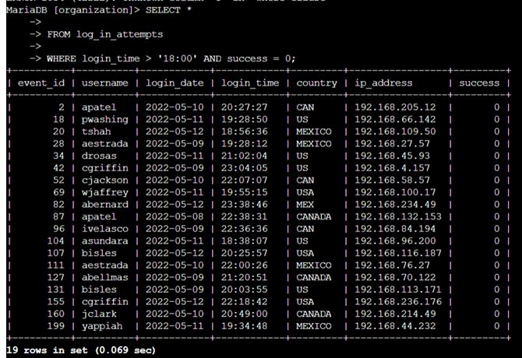

## Retrieve login attempts on specific dates

SELECT *

FROM log_in_attempts

WHERE login_date = '2022-05-08' OR login_date = '2022-05-09';



## Retrieve login attempts outside of Mexico

SELECT *

FROM log_in_attempts

WHERE NOT country LIKE 'MEX%';

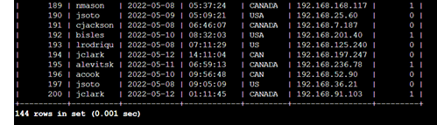

## Retrieve employees in Marketing

SELECT *

FROM employees

WHERE department = 'Marketing' AND office LIKE 'East-%';

## Retrieve employees in Finance or Sales

SELECT *

FROM employees

WHERE department = 'Finance' OR department = 'Sales';

## Retrieve all employees not in IT

SELECT *

FROM employees

WHERE NOT department = 'Information Technology';

## Summary

This project showcases the use of SQL filtering techniques to retrieve specific login and employee data efficiently. By applying AND, OR, and NOT operators, we enhance data analysis for security monitoring and workforce management.